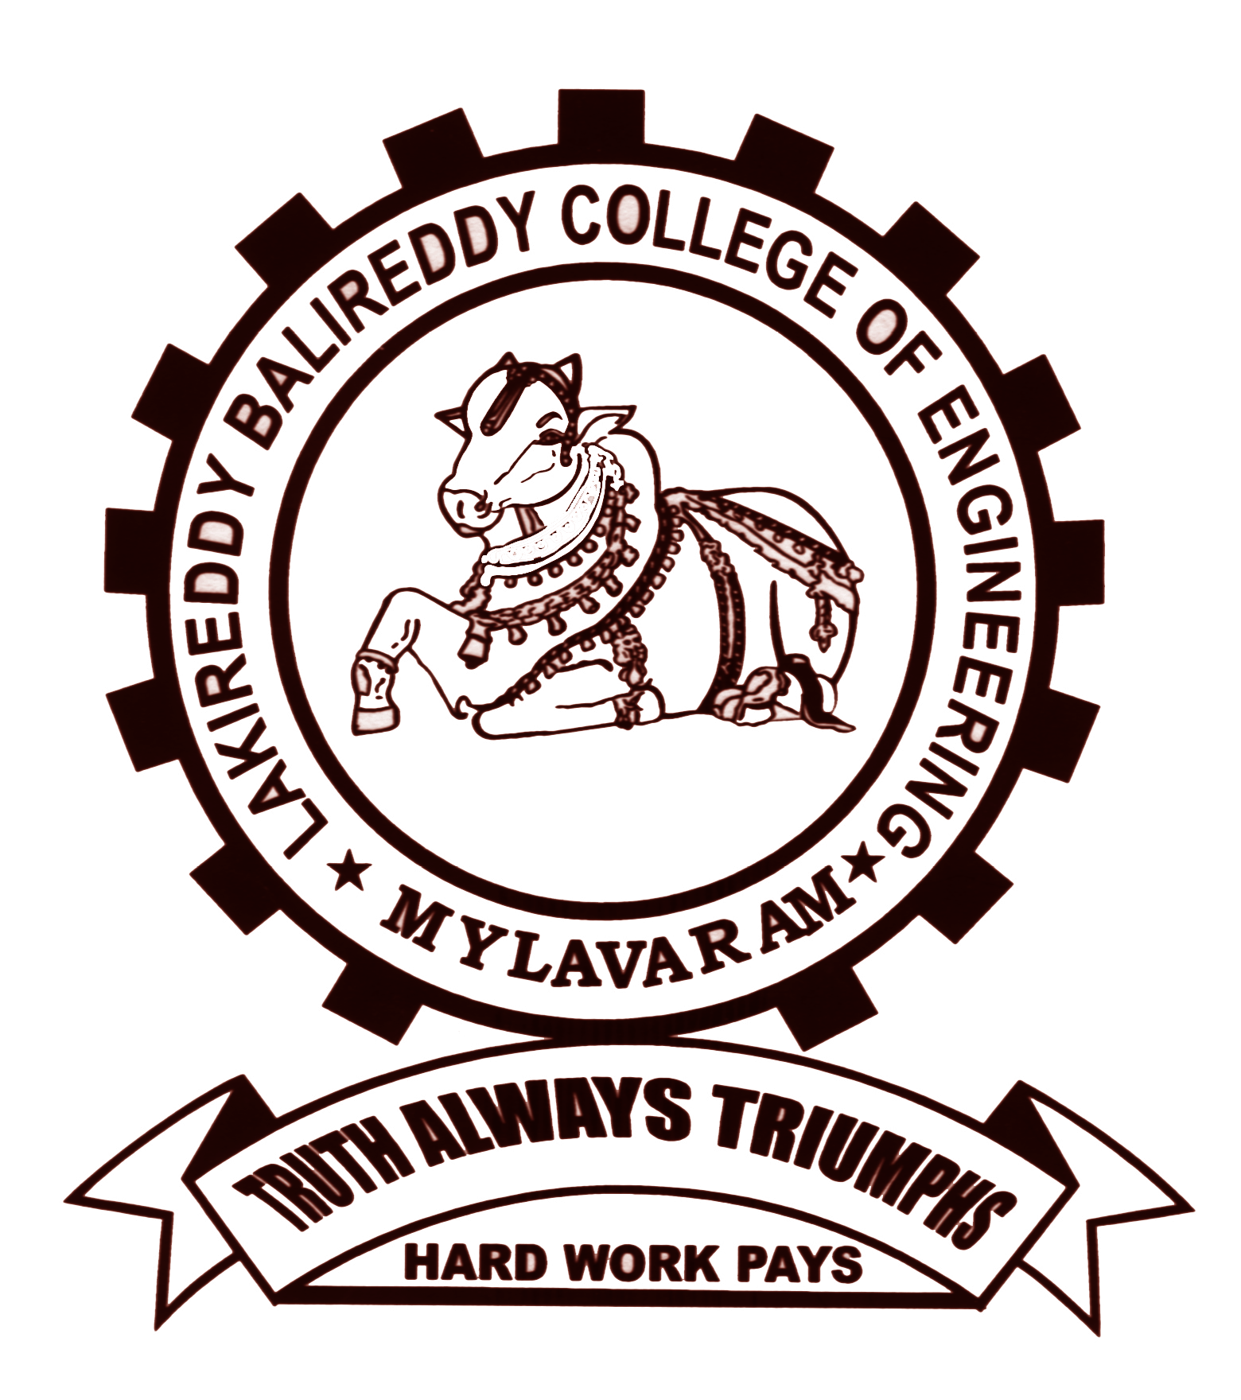
LAKIREDDY BALI REDDY COLLEGE OF ENGINEERING (Autonomous)
L.B. Reddy Nagar, Mylavaram-521 230. Andhra Pradesh, INDIA
Affiliated to JNTUK, Kakinada & Approved by AICTE New Delhi
Accredited by NBA, New Delhi & Certified by ISO 9001:2015, http://www.lbrce.ac.in

DEPARTMENT OF ELECTRICAL & ELECTRONICS ENGINEERING

Course: B.Tech Semester: I Code: 23EE04 Academic Year: 2023-24
Course Title: Basic Electrical & Electronics Engineering Branch: AI&DS B section
UNIT-II : OBJECTIVE QUESTIONS
S.No. | Question | Option 1 | Option 2 | Option 3 | Option 4 | Answer (1/2/3/4)
1 | A _______________ is a machine which converts Mechanical Energy into Electrical Energy. | Generator | Motor | Transformer | none of these | 1
2 | A _______________ is a machine which converts Electrical Energy into Mechanical Energy. | Generator | Motor | Transformer | none of these | 2
3 | Whenever a conductor cuts magnetic flux and _______ is induced in that conductor. | current | EMF | Flux | Speed | 2
4 | As per Faraday's laws of electromagnetic induction, an e.m.f. is induced in a conductor whenever it | Lies perpendicular to the magnetic flux | Cuts magnetic flux | Lies in a magnetic field | Moves parallel to the direction of the magnetic field | 2
5 | The total number of magnetic field lines passing through an area is termed as? | Voltage | EMF | Magnetic Flux | none of these | 3
6 | What does emf stand for? | Electronic magnetic force | Electromotive force | Electromagnetic force | none of these | 2
7 | What is an emf? | Voltage | Force | Current | Speed | 1
8 | The operation of the electric generator and motor is based on the interaction between | Magnetic field and electric field | Magnetic field and electric current | Electric field and law of induction | Law of induction and dynamo-electric principle | 2
9 | Direction of rotation of motor is determined by ____________ | Faraday’s law | Lenz’s law | Coulomb’s law | Fleming’s left-hand rule | 4
10 | Which part will surely tell that given motor is DC motor and not an AC type? | Winding | Shaft | Commutator | Stator | 3
11 | A conductor is rotating within a magnetic field. At which of the position do the peak voltages occur? | At right angles to the axis of magnetic field | Along the axis of the magnetic field | At 45⁰ angles to the axis of magnetic field | Anywhere | 2
12 | Which of the following is not a part of dc machine? | Armature | Commutator | Field winding | Damping winding | 4
13 | A transformer | Steps up or down dc voltages | Changes ac to dc | Steps up or down ac voltages | Changes dc to ac | 3
14 | Which of the following does not change in an ordinary transformer? | Current | frequency | Voltage | All of the Above | 2
15 | Rotating magnetic field is produced in a | Three phase induction motor | DC motor | DC Generator | transformer | 1
16 | Alternator operates on the principles of | Electromagnetic induction | Self-induction | Mutual induction | Self or mutual induction | 1
17 | The armature of an alternator | Field system | Armature | Armature as well as field system | None of the above | 1
18 | The deflection torque in moving coil instrument is proportional to _______________? | Current | Voltage | Square of the current | None of the above | 1
19 | Which one of the following instruments is a spring-controlled instruments? | Moving coil | Moving iron | Both A&B | None of the above | 3
20 | Which one of the following instruments is suitable for both dc as well as ac? | Moving coil | Moving iron | Both A&B | None of the above | 1
21 | Which one of the following meters is used to measure the current? | Voltmeter | Ammeter | Both A&B | None of the above | 2
22 | Which one of the following meters is used to measure the Resistance? | Moving coil | Moving iron | Wheatstone Bridge | Both A&B

COURSE INSTRUCTOR | COURSE COORDINATOR | MODULE COORDINATOR | HOD
Dr.AVGA.Marthanda | Dr.AVGA.Marthanda | Dr. G.NAGESWARA RAO | Dr. J.S.V.Prasad

